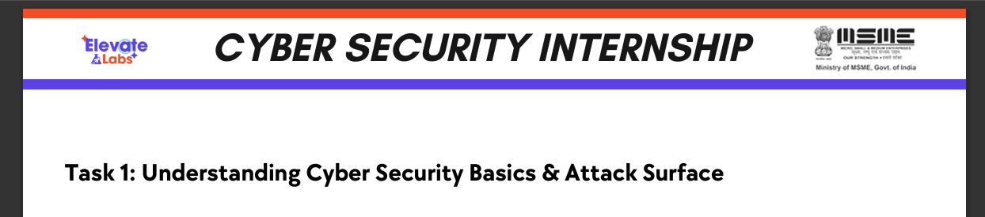

What is CIA Triad:
CIA stands for- Confidentiality, Integrity, Availability. This CIA triad defines the Foundations of Cyber Security.
Confidentiality ensures the data is accessed only by Authorized Users. Like keeping the data safe from Unauthorized access.
Real-World Examples:
Banking Apps- Only We can see our account bank balance, and the ATM Pin will be a Confidential one.
Social Media-We will keep our personal chats confidential, we won‘t be allowing any other unauthorized persons to see the message.
Integrity ensures the data remains accurate, complete, and unaltered unless modified by authorized users. It keeps the data tamper proof.
Real-World Examples:
If a hacker tries to change your personal details from the government database. It can be prevented by Hashing, Digital signatures,Access control.
Availability ensures that systems and data are accessible when required.It makes the data is available for the users whenever needed.
Real-World Examples:
Bank servers must be online 24/7, it should be available to the users 24*7.

Types of Attacks:
The types of Attackers describes the persons who performs different type of cyber attacks and their motives.
- Script Kiddies: Use ready-made tools with limited knowledge.
Example: Using phishing kits to steal social media passwords.
- Insiders: Employees abusing authorized access.
Example: Bank staff leaking customer data.
- Hacktivists: Attack for political or social motives.
Example: Defacing government websites.
- Nation-State Actors: Highly skilled, government-backed attackers.
Example: Targeting national banking or power systems.
Attack Surface:
Attack surfaces are points where attackers can enter a system.
- Web Applications: Login forms and payment pages.
Example: Online banking portals.
- Mobile Apps: Insecure storage or weak authentication.
Example: Banking or social media apps.
- APIs: Data exchange interfaces between apps and servers.
- Networks & Cloud: Open Wi-Fi or misconfigured cloud storage ,every exposed component increases risk, so minimizing attack surfaces improves security.

